# Unit #3 Homework

## Homework 3:5 Minidialogue (pg120-121)

## Homework 3:7 Identify and Draw (pg125)

## Homework 3:8 How many of What? (pg129)

## Homework 3:9 Minidialogue (pg133)

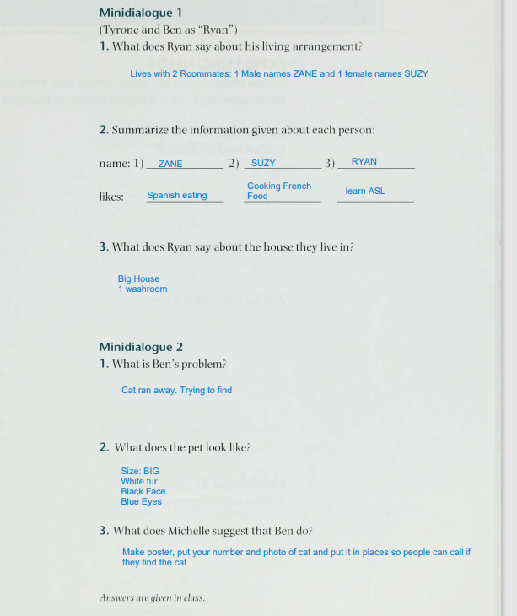

## Homework 3:10 Minidialogue: Expressing Needs (pg134-135)

## Homework 3:10 Study Corner (pg137)

## Homework 3:12 Minidialogue (Pg 144)

## Homework 3:15 What is the sign (Pg151)

